APSRTC RESERVATION SYSTEM

Group Members:
Name Register Number Role
K. Pavani 164g1a0567 Analyser
N. Pragathi 164g1a0568 Customer
K. Praneetha 164g1a0569 Customer
Y. Premalatha 164g1a0570 D.B.A
G. Priya Ranjan Reddy 164g1a0571 Designer
E. Rajesh 164g1a0572 Designer
Under the guidance of
Mr. P. Veera Prakash M.Tech.,
Assistant Professor


Department of Computer Science and Engineering

SRINIVASA RAMANUJAN INSTITUTE OF TECHNOLOGY
(Approved by AICTE & Affiliated to JNTUA & Accredited NAAC 'A' Grade )

Index

S.No Title Page Number
01 Customer requirements 04
02 Entities of the database 05-06
03 ER diagrams of database 07-08
04 ER diagram of application 09
05 Relation between entity sets 10
06 Schema of database 11
07 Creating the tables 12-13
08 Applying referential integrity constraints 14
09 Describing thetables 15
10 After inserting the values into the tables 16
11 Query output 17
12 Conclusion 17

INTRODUCTION
Our bus travel facility provides online bus thicket reservation systemIn our system we can manage all types of passenger,bus,reservation
All details that is related to travelling like fare details,seat vacancy,bus details,no of seats is maintained.
Our system provide the facility like bus boarding.
Our travel system provides the transportation facility to the customer based on their requirements.

The charges also depend on the distance the customer wants to travel.

They maintain all the records of the bus reservation counter through online service.

Until now they use to issue the tickets in the buses alone it is difficult to track the details of the bookings done as it provides the service all over the state.

01 . CUSTOMER REQUIREMENTS
1. Passenger address and contact number should be maintained.
2. The bus routes should be maintained.
3. Admin should manage the details of bus, passenger, bus fare reservation id should be unique and notnull.
4. The bus timings,arrival,departure should be visible to all who access the details.
5.minimum cost of the busfare is Rs.100/-

02. THE ENTITIES AND ATTRIBUTES OF APPLICATION :

The application APSRTC RESERVATION SYSTEM consist of :
ENTITIES:

1. Passenger
2. Reservation
3. Bus

ATTRIBUTES:

1. Passenger:
- p_id
- p_name
- p_phonenumber
- p_address
- p_age
- p_gender
2. Reservation
- p_id
- r_date
- r_origin
- r_destination
- r_seatno
- r_arrivaltime
- r_departuretime
3. Bus:
- busno
- vacant
- origin
- destination
- arrival
- departure
- no of seats

PRIMARY KEYS:
In passenger entity the primary key is pid.
In reservation entity the primary key is pid
In bus entity the primary key is busno
SUPER KEYS:
Passenger:pid,name
FOREIGN KEYS:
Busno ,pid

3. ENTITY DIAGRAMS

ER DIAGRAM OF ENTITY PASSENGER:

P_age
P_gender
Passenger
P_id
P_name
P_address
P_address
P_name

P_id
Passenger

Figure2.1 passenger entity set

ER DIAGRAM OF RESERVATION ENTITY:
origin
rdate
destination
BUS
busno
seatno
arrival
departure
pid

Reservation
Figure2.2 reservation entity set

ER DIAGRAM OF BUS ENTITY:

arrival
destination

origin
bus no
no of seats
BUS
departure
Figure2.1 p
vacant seats
Figure2.3 bus entity set

4. TOTAL ER DIAGRAM:

HAS
(1,1)
RESERVATION
PASSENGER

(M,1)
for

BUS
Figure 2.4

05. RELATION BETWEEN ENTITIES
A relationship is how data is stored between entities.
The relations in our databases are:
Has:
The relationship ‘has’ is in between passenger and reservation. Here we maintain one to one relationship.
It is because each passenger must have one reservation. So we maintain one to one relationship.
For:
The relationship ‘for’ is in between reservation and bus. Here we
Maintain many to one relationship.

6. SCHEMA OF THE DATABASE:
Passenger:pid:varchar2(5),pname:varchar2(30),paddress:varchar2(100),age:number,gender:varchar2(2)
Reservation:pid:varchar2(5),rdate:DATE,origin:varchar2(20),destination:varchar2(20),arrival varchar2(8),departure varchar2(8),seatno number(3)
Bus:busno:varchar2(10),origin varchar2(20),destination varchar2(20),arrival varchar2(8),departure varchar2(8),no of seats number(3),vacant number(3)busfare number(4)

07.CREATING TABLES
Syntax for creating relations:
Syntax:
CREATE TABLE tablename (
column1 data_ type [constraint] [,
column2 data_ type [constraint] ] [,
PRIMARY KEY (column1 [, column2]) ] [,
FOREIGN KEY (column1 [, column2]) REFERENCES tablename] [,CONSTRAINT constraint]);

Creating relations:

The relation for the entity passenger:
1.create table passenger(
Pid varchar2(5) primarykey,
Pname varchar2(30) notnull,
Paddress varchar2(100),
Age number(3),
Gender varchar2(2));
Table created.

The relation for the entity reservation:
2.create table reservation(
Pid varchar2(5) primary key,
Rdate DATE,
Origin varchar2(20),
Seat no number(3),
Destination varchar2(20),
Arrival varchar2(8),
Departure varchar2(8));
Table created.
The relation for the entity bus:
3.create table bus(
Busno varchar2(10) primarykey,
Origin varchar2(20),
Destination varchar2(20),
Arrival varchar2(8),
Departure varchar2(8),
No_ of_ seats number(3),
Vacant number(3),
Busfare number(4) );
Table created.

08.APPLYING REFERENTIAL INTEGRITY CONSTRAINTS

- alter table reservation
add constraint fk_pid foreign key(pid) references passenger;

This makes p_ssn as the foreign key for reservation entity

- alter table reservation
add constraint fk_busno foreign key(busno) references bus;

This makes train_no as the foreign key for reservation entity

08.DESCRIPTION OF THE TABLES:
PASSENGER:
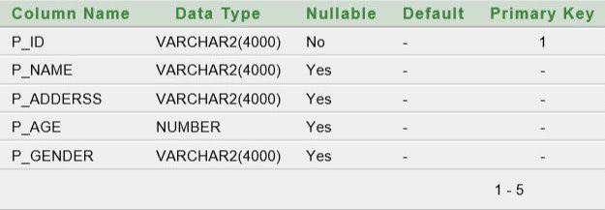
BUS :
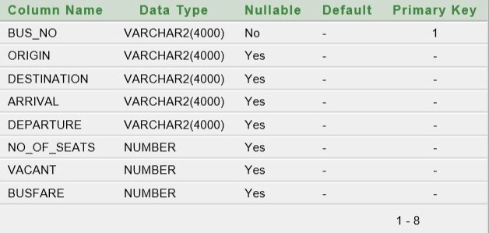RESERVATION:
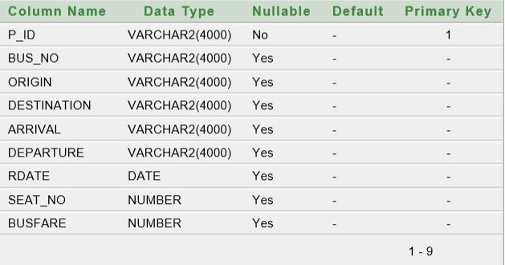

08.TABLES AFTER INSERTING THE VALUES:
PASSENGER:
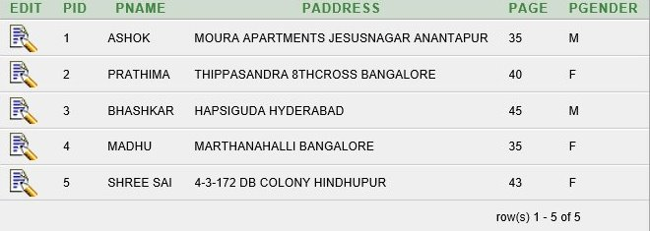BUS:
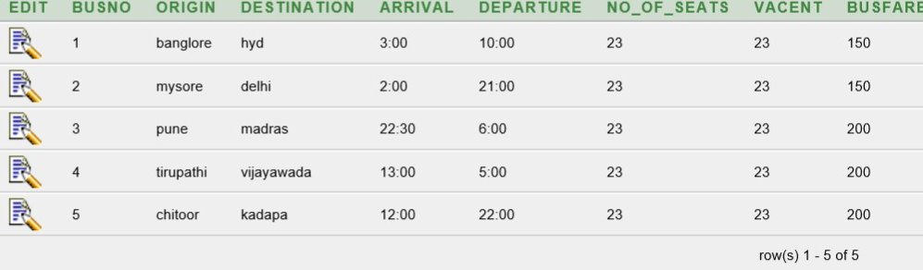
RESERVATION:
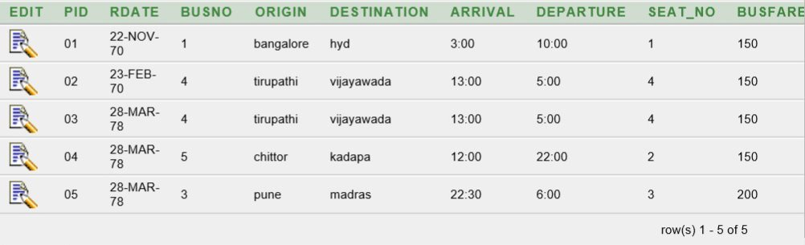

09. QUERY OUTPUTS
Find no. Of passengers who reserved the seat on 23-feb-70
SELECT R.pid from reservation R
WHERE rdate=’23-feb-70’
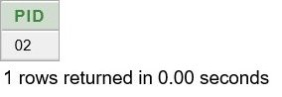
CONCLUSION:
The project on creating the database on apsrtc reservation system is completed successfully.

